Home About Us Contact Us Stores Italian Website
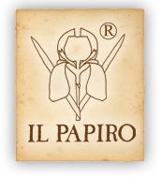Catalog Printing Custom Orders Wholesale Corporate Franchising As Featured In

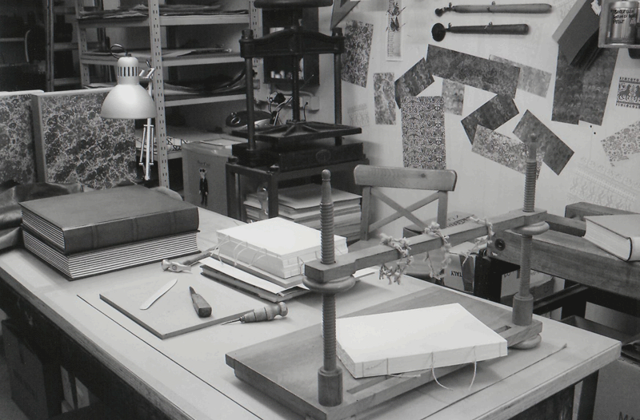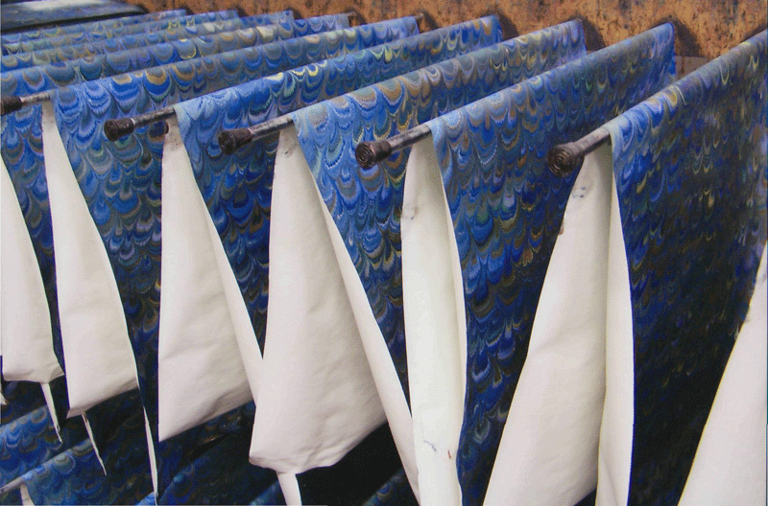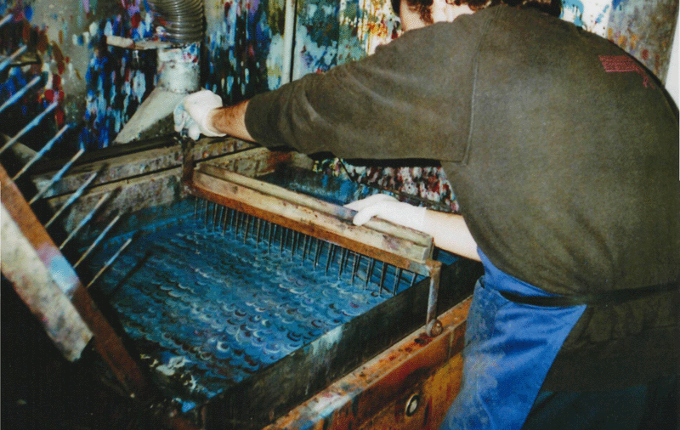

IL PAPIRO is a company which produces items in hand decorated paper with techniques inspired
by the tradition of Tuscany. Established 1976, in Firenze, Italy, IL PAPIRO introduced items utilizing almost extinct techniques such as the marbleizing of paper. This, in turn, contributed to the renewed taste for items in hand decorated paper.
The highly artisan production of IL PAPIRO covers a variety of items from bound diaries, photo albums, desk accessories, frames, keepsake boxes and stationery. Our items are produced following methods and procedures in the best tradition of Italian craftsmanship. The marbleized papers are hand decorated using the XVII century technique "paper a la cuve". The books and the other items are made with the papers we produce with the best traditional materials available. Our stationery and cards are printed with great care using different printing techniques, on watermarked papers and 100% cotton card stock of excellent quality.
All items are produced in Firenze for the past 37 years and now supply hand marbleized papers to a worldwide audience.
At the present time, there are 14 stores in Italy, 2 in the United States one in London and one in Australia.
We are thrilled to be a part of this great family of wonderful artisans for the past 29 years and hope to continue providing you with the best Italy has to offer in hand decorated papers.

Home Catalog Contact Us Privacy

