Home About Us Contact Us Stores Italian Website

Catalogue Printing Custom Orders Wholesale Corporate Franchising As featured In
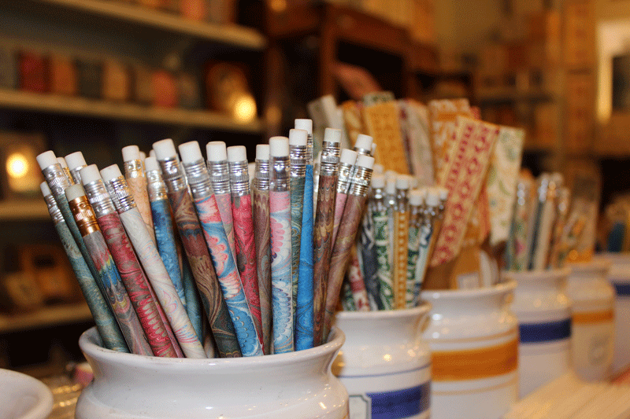

Email us or call us for more personal attention at:
IL PAPIRO – 1021 Lexington Avenue, New York, NY 10021
Store Hours: Mon – Sat: 10am-6pm
Tel:212.288.9330
Fax: 212.570.1587
Toll free: 866.472.7476
Email:info@ILpapirofirenze.com
IL PAPIRO – 347 Worth Avenue, Palm Beach, FL 33480
Store Hours: Mon – Sat: 10am – 6pm
Tel: 561.833.5696
Fax: 561.833.5829
Toll Free: 877.257.8056
Email: info@ILpapirofirenze.com

Home Catalog Contact Us Privacy

