Home About Us Contact Us Stores Italian Website
Catalog Printing Custom Orders Wholesale Corporate Franchising As featured In

Where to find our stores all over the world:
United States:

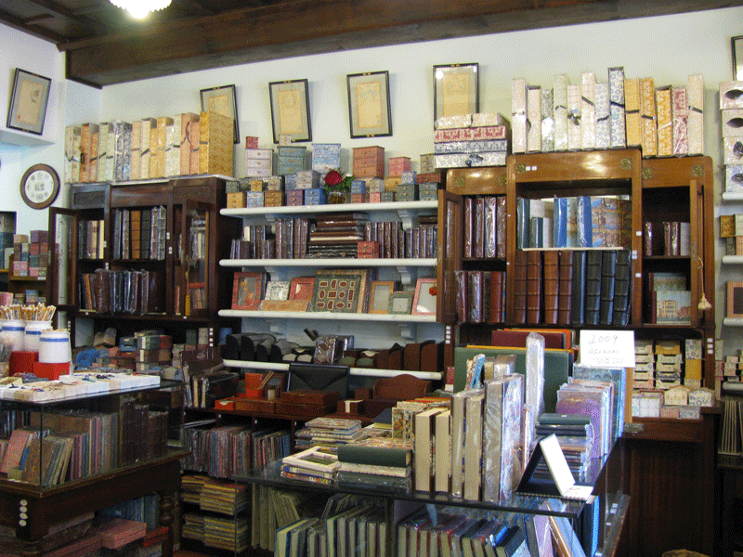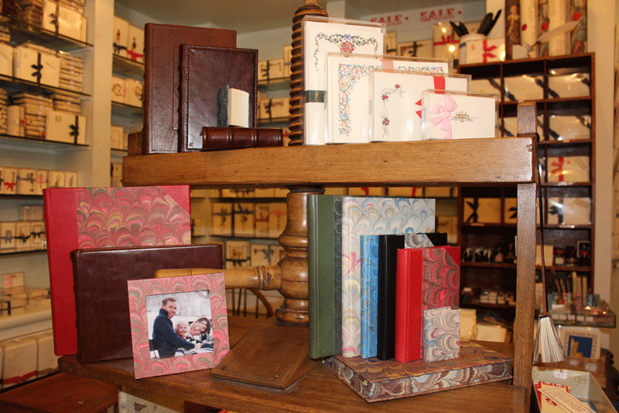 IL PAPIRO 1021 Lexington Avenue, New York, NY 10021
Tel:212.288.9330
Fax: 212.570.1587
Toll free: 866.4.Papiro
www.ILpapirofirenze.com
Email: info@ILpapirofirenze.com

IL PAPIRO 347 Worth Avenue, Palm Beach, FL 33480
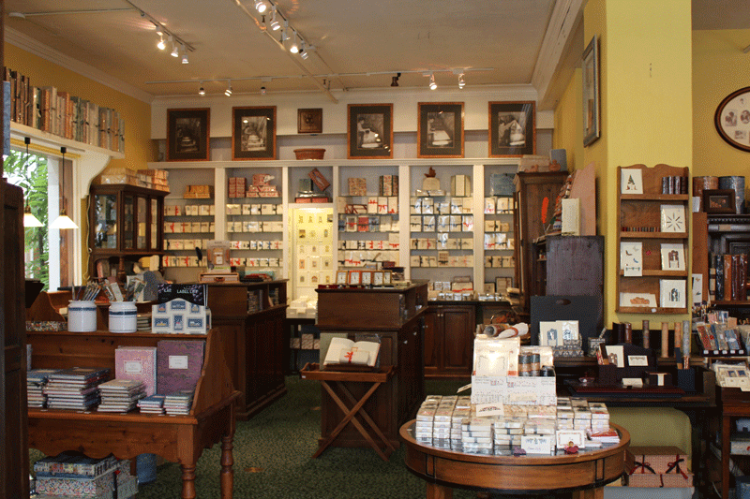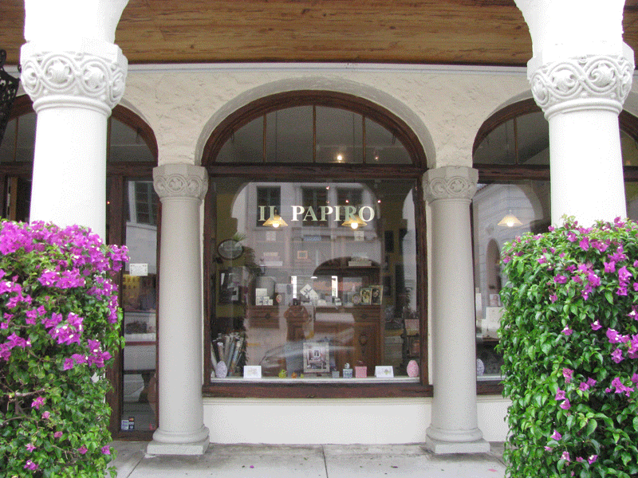 Tel: 561.833.5696
Fax: 561.833.5829
Toll free: 877.257.8056
www.ILpapirofirenze.com
Email: info@ILpapirofirenze.com

Italy:
IL PAPIRO
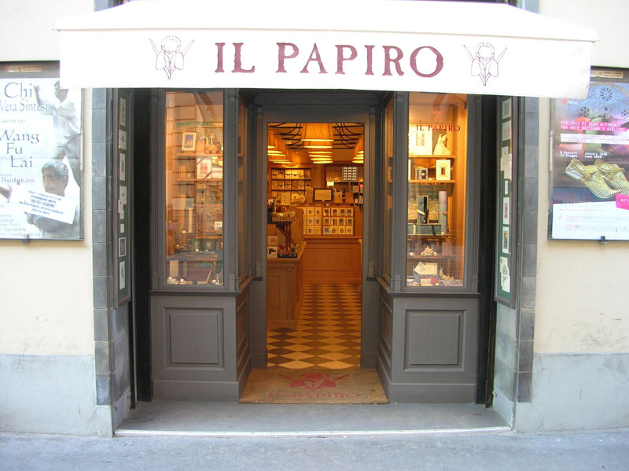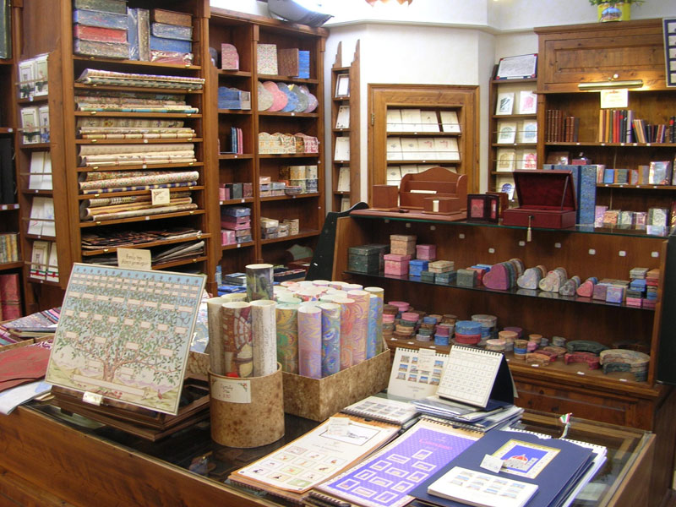 Florence , Rome, Venice, Pisa, Cortona, Orvieto, Siena
49r Via Cavour, Firenze
Tel: 055.215262
www: ILpapirofirenze.it

Home Catalog Contact Us Privacy

